You are provided with data of Top ODI Players of Pakistan in a file “Batsman.txt”. This file contains player's name, number of matches played by a player, runs, highest score and number of centuries. Each column in the file is separated by a tab.

**Batsman.txt**

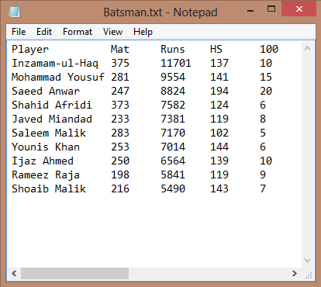

**Write code for following tasks: (Functions are mandatory)**

1. Create five arrays for Name, Matches, Runs, Highest Score and Centuries. Assume maximum number of players can be 10. Assume index i of all arrays contains data of same player.
2. Read data from file into corresponding arrays.
3. Print the content of all arrays on console in the same format as shown in the input file.
4. Display on console the record of the player with maximum highest score.
5. Display on console the average number of matches played by Top Pakistani Batsman.
6. Sort the data of all players with respect to overall runs in **ascending order**.
7. Print the data in an output file with name “Output.txt” Your output file must contain data in the following format:

**Name<tab>Matches<tab>Runs<tab>Highest Score <tab>Centuries**